News

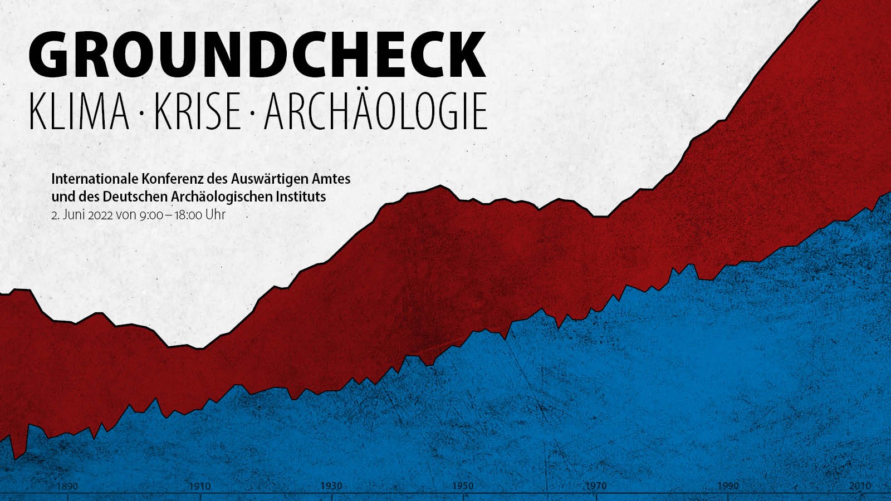**Groundcheck AA 2.6.** (Einladungstext m.H. google übersetzt)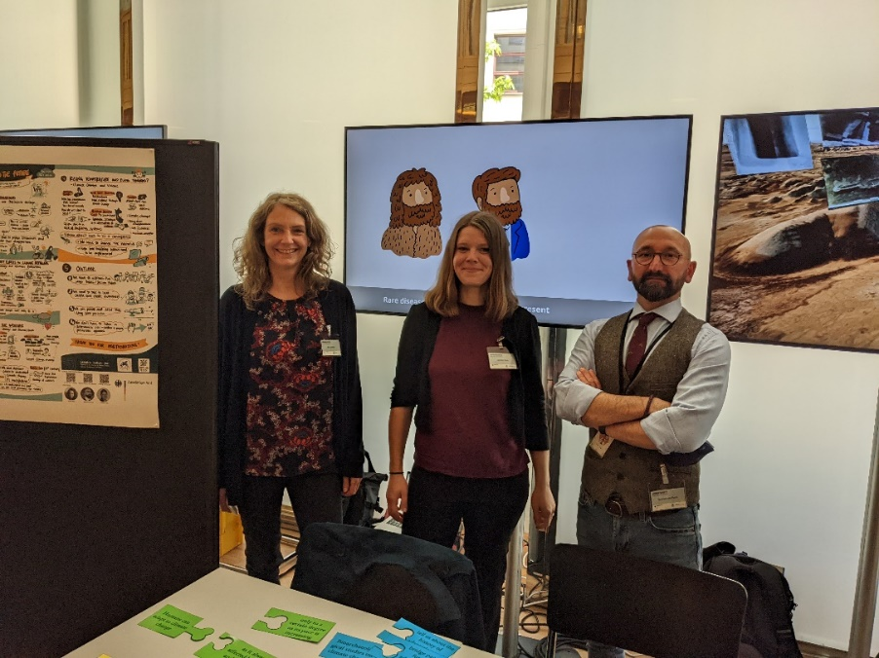

With increasing speed and simultaneity, we are experiencing dramatic climate and social changes. Science and politics are challenged to defend these findings against denial and fake science, which makes solutions even more difficult. The conference is intended to take a look at the specific regional effects of global climate change and use current examples from international research and a long-term perspective to show what climate change has meant for societies in the past - and still means today. Understanding sustainable solutions from earlier societies and making them usable for our present and future is also a topic of the conference, as is finding sustainable solutions to protect cultural assets from climate change.

The team of the Human Bioarchaeology of the German Archaeological presented the results of the Back(Bone) to the future conference back in December 2021.

See a press release here. (<https://www.tagesspiegel.de/wissen/auch-das-kulturelle-erbe-indigener-gemeinschaften-ist-bedroht-8022256.html>)

**DAARD (Digital Atlas of Ancient Rare Diseases) now online!**

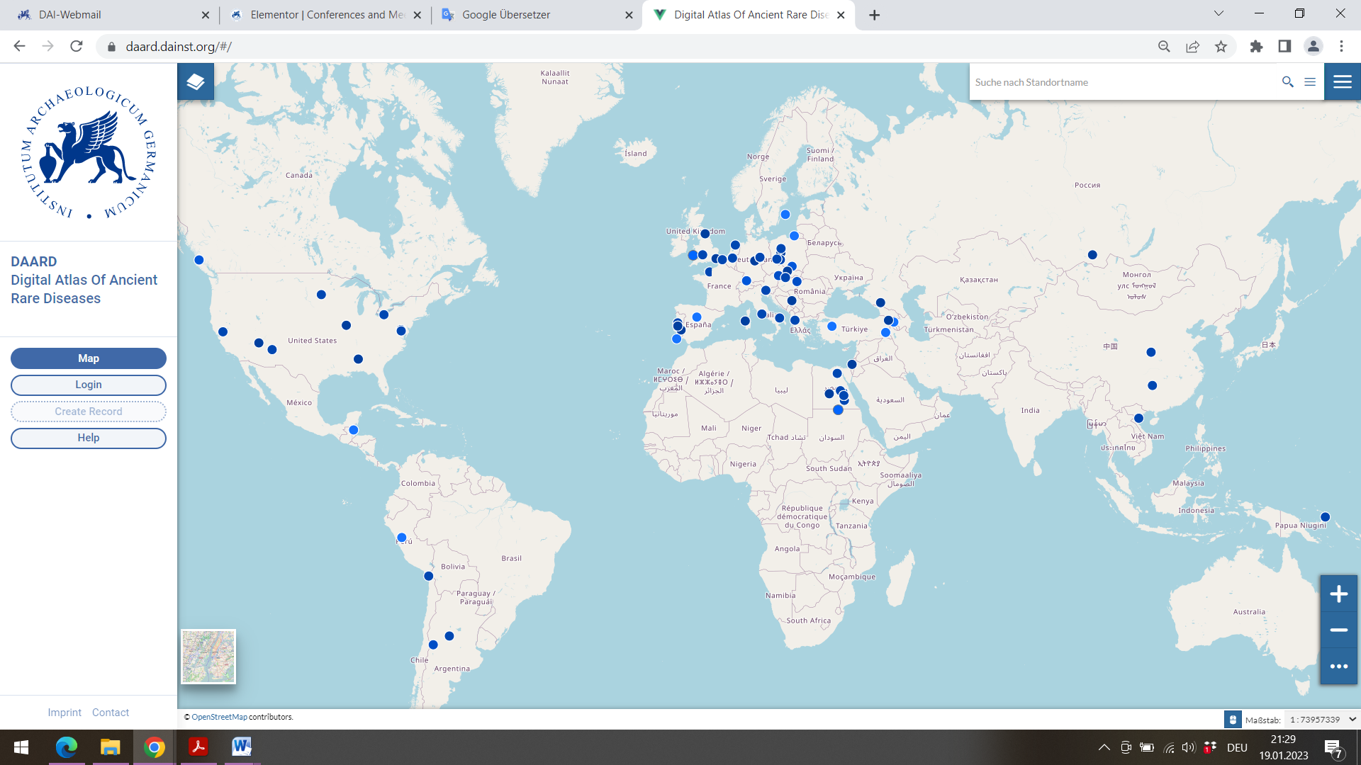

The DAARD is available online! Around 80 archaeological cases from so far eight rare diseases affecting the skeleton can be viewed worldwide with all available osteological and archaeological data. Anyone can be part of the DAARD by submitting a case of a rare skeletal disease and making it available to researchers. Thus, the DAARD is a constantly growing tool for research, but also an opportunity to make your own cases available and more visible.

Enter DAARD here. (<https://daard.dainst.org/#/>)

**Clustertagung Körper und Tod: Konzepte in Berlin**

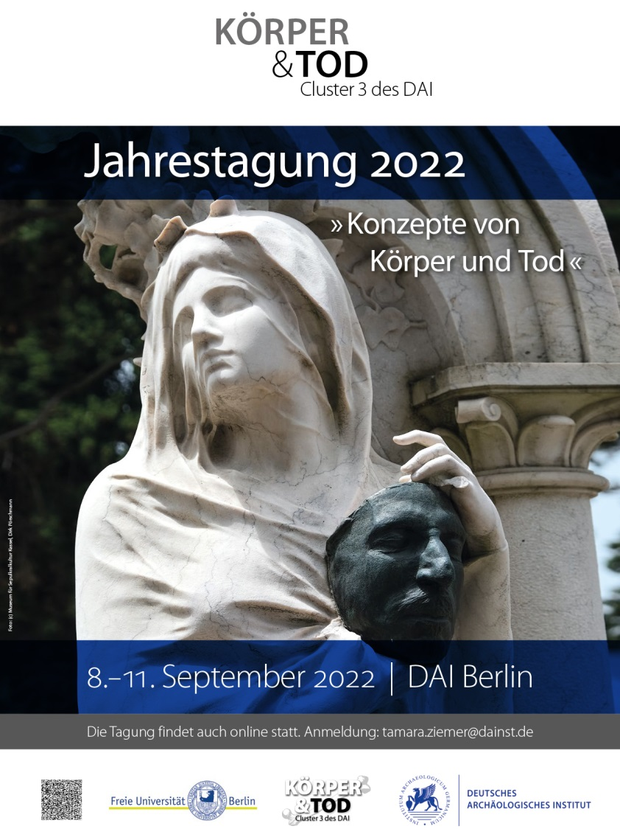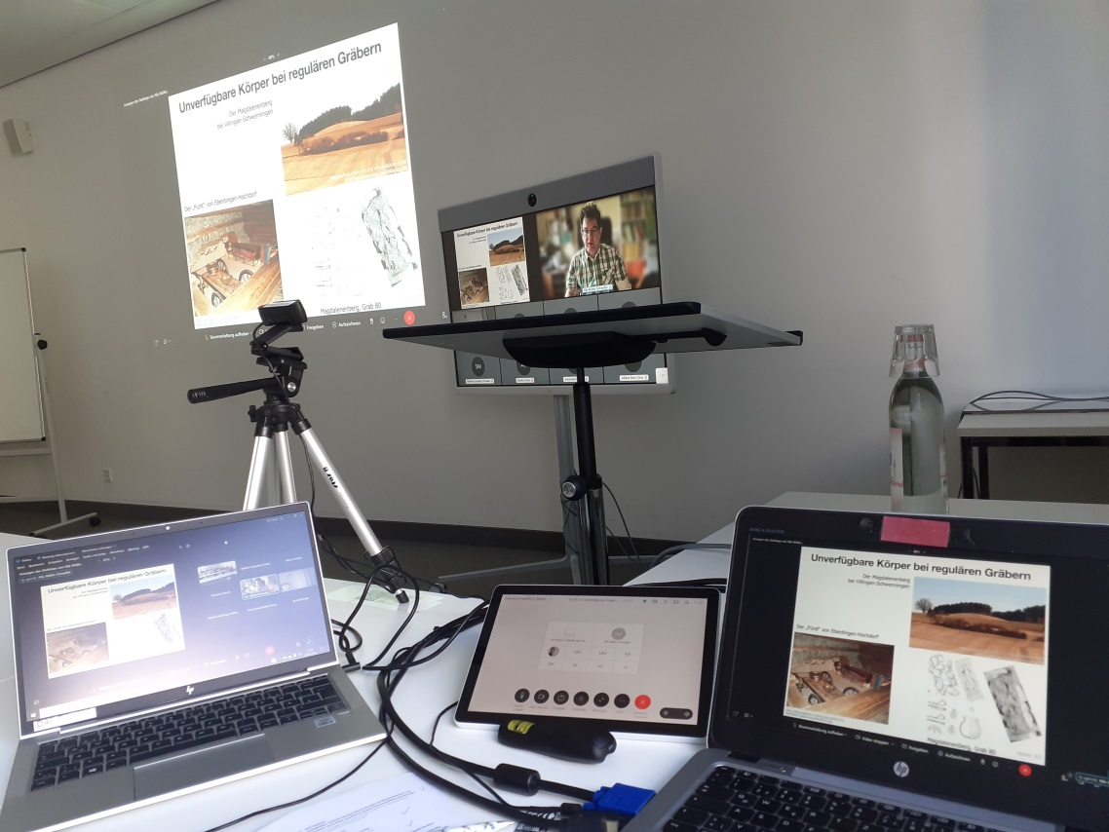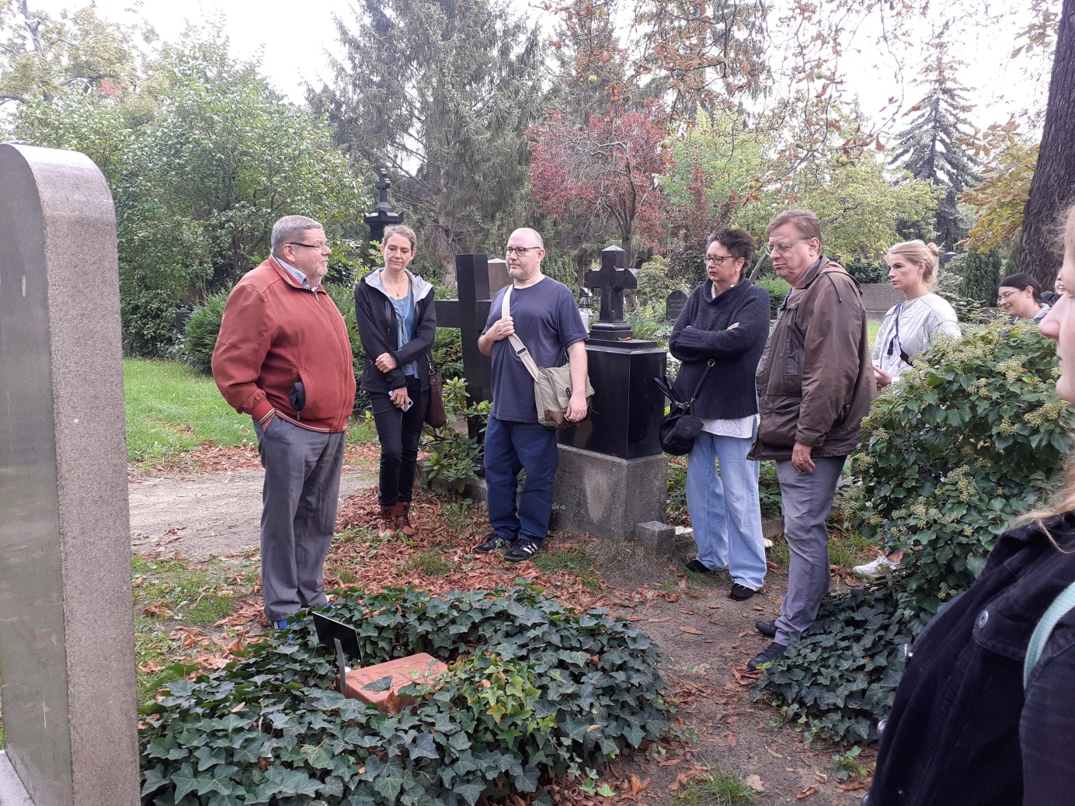

In September 2022, the Human Bioarchaeology group of the DAI Berlin hosted the first international hybrid conference of the Cluster Body and Death of the DAI. Lectures on ancient and modern concepts of the body, dying and death. The participants met on the premises of the Freie Universität Berlin and the lively discussions were continued in the surrounding restaurants in the evening. As excursion a guided tour of the cemeteries at Hallesches Tor.

See information about the “Cluster 3: Körper und Tod” here. (<https://www.dainst.org/en/forschung/netzwerke/forschungscluster/cluster-3/veranstaltungen>)

Siehe Gramsch